FEATURE WEATHER PREDICTION USING MACHINE LEARNING

MGT-665-NW2: Solv Probs W/ Machine Learning Graduate Midland Spring 2023-2024
Course Instructor - Dr. Mohammad Nasim

Presented by –

Nidharsan Reddy
Master’s in business Analytics, at Northwood University
papireddypn50@northwood.edu

Sai Mahitha Kopuru

Master’s in business Analytics, at Northwood University

kopurus86@northwood.edu

Krishna Vardhan

Master’s in business Analytics, at Northwood University

nettimikv19@northwood.edu

Vineeth Goud

Master’s in business Analytics, at Northwood University

bodav90@northwood.edu

Abstract:
The purpose of this paper is to discuss about weather prediction using Machine Learning.
Since they can save us money, time, property, or even our lives, weather forecasts have become more and more important in recent years. Even though there are a lot of weather stations in America, most of them are found in populated areas like cities, suburbs, or towns. This results in less accurate weather forecasting in remote areas, which can be problematic for people like farmers who depend heavily on weather reports for their daily tasks. We are using machine learning techniques such as Random Forest, to analyze features such as temperature, apparent temperature, humidity, wind speed, wind bearing, visibility, and cloud cover in order to predict the weather in this paper. In light of the findings, a comparative study is done concerning the accuracy.

Keywords: Weather prediction, Random forest, Linear regression, Weather forecasting

I.INTRODUCTION

Weather forecasting involves collecting and analyzing data from various sources to make informed predictions about future weather conditions. In the past, pattern extraction from data sets was done by hand. In the current computer era, data collection, manipulation, and storage have greatly increased. This leads to an extremely sophisticated pattern recognition. Data mining is the computerized use of specialized algorithms to find particular patterns in large amounts of data. One kind of data mining is machine learning, where a model is built by having a computer learn concepts. Using the learning principle, this model predicts future data instances by training and testing on the large data sets that are provided. Modeling is the process of developing a classification model to predict a result. In order to predict the value of a target categorical variable, classification is the data mining process of building a model based on one or more attributes of categorical variables. This is capable of classifying the provided data based on the training set and class labels. The weather in one place can have a big impact on the weather in other places because weather systems can travel great distances in all directions over time. In this paper, we propose a way to forecast weather conditions by fusing historical meteorological data from one city with data from neighbouring cities.
By combining these data, basic machine learning models that accurately predict the weather for the ensuing few days can be constructed. These straightforward models can be used to produce fast, precise forecasts that we can use in our daily lives on inexpensive, limited computing systems.

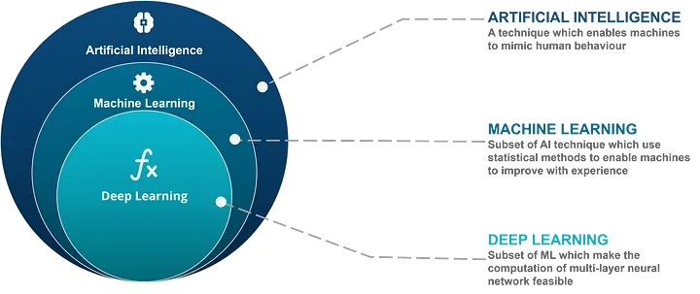
Figure 1 - Relationship between AI, ML, and DL

II. PROBLEM STATEMENT

i.Due to its ability to predict future weather conditions, weather forecasting is essential in many industries, including disaster relief, transportation, and agriculture.
ii. Accurate weather prediction is still difficult because of the atmosphere's complexity and dynamic nature, despite advances in meteorological science and technology.

iii. The majority of current weather forecasting techniques rely on numerical weather prediction models, which are computationally intensive and can still result in uncertainties and inaccuracies, particularly for localized and short-term forecasts.

iv. Therefore, more research is required to investigate novel strategies that make use of machine learning and data-driven methodologies to progress the field of weather forecasting, solve current issues, and optimize the advantages that society will derive from increased weather prediction accuracy and dependability.

III.RESEARCH DESIGN & METHODOLOGY

Our objective is to predict the future weather using the data available from the previous weather forecasting, and for this we have used the data available in the website NOAA( National Oceanic and Atmospheric Administration). Using traditional methods for weather forecasting have limitations that can be discussed below.
I. Complexity of Atmospheric Systems: The atmosphere is a highly complex and dynamic system, with numerous interacting variables that make it challenging to accurately predict weather patterns.
ii. Limited Data Sources: Traditional weather forecasting relies on a limited number of data sources, such as ground-based weather stations and satellite observations, which can be sparse or incomplete.
iii. Computational Limitations: The computational power required to model and simulate the entire atmosphere in real-time has been a major challenge for traditional weather forecasting methods.

MACHINE LEARNING ALGORITHMS USED
- We have used Random Forest algorithm to obtain the desired future predictions of the weather.
- Random Forest builds multiple decision trees during training.
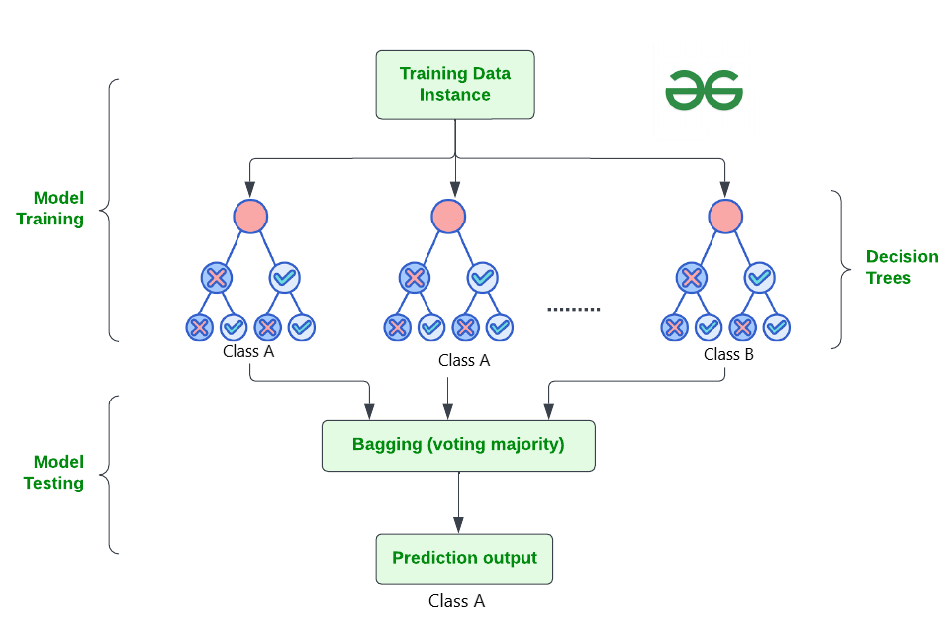
Figure 2 - Random forest

- Each tree is trained on a random subset of the training data and a random subset of the features.
- During prediction, each tree in the forest independently predicts the target variable and the final prediction is determined by averaging or voting across all trees.
- Complex, nonlinear relationships between input variables (such as temperature, humidity, and wind speed) and the target variable (such as precipitation, temperature change) are frequently involved in weather forecasting. By recursively partitioning the feature space into regions that are progressively more homogeneous with respect to the target variable, Random Forest is able to capture these nonlinear relationships.

TECHNICAL ARCHITECTURE
Preprocessing and Data Ingestion:
Sources of Data: The Pandas library is used by the system to ingest meteorological data from a CSV file.The dataset includes historical weather records with the following features: maximum temperature (tmax), minimum temperature (tmin), wind speed (awnd), precipitation (prcp), snowfall (snow), and snow depth (snwd).
Prior to processing: The first step of preprocessing is to convert the index to datetime format, forward-fill missing values, convert column names to lowercase, and filter out columns with fewer than 5% missing values.
Model Training and Evaluation:
Random Forest Regression: To predict the minimum temperature (model_tmin) and maximum temperature (model_tmax), two Random Forest Regressor models are trained independently. Every model is trained on historical data (from 2000 to 2023) with a fixed random state (random_state = 42) and 100 decision trees (n_estimators).
Using the characteristics for that year, the trained models are used to forecast the minimum and maximum temperatures for 2024. Then, for evaluation, the predicted and actual temperatures are compared.

IV.SYSTEM DEVELOPMENT:

Information was gathered from a CSV file that contained historical weather records that NOAA had provided.
The preprocessing procedures comprised lowering the case of column names, forward-filling missing values, and eliminating columns with fewer than 5% missing values.
Target variables (target_tmin and target_tmax) were generated by shifting the tmin and tmax columns after features were engineered.

Using historical data spanning from 2000 to 2023, the trained models were assessed using performance metrics like mean absolute error (MAE) and root mean square error (RMSE).
To ensure generalization performance, models were validated against unobserved data.

EVALUATION METRICS

Evaluation metrics for TMIN:
Mean Absolute Error (MAE): 3.2340950424005213
Mean Squared Error (MSE): 17.324850014899976
Root Mean Squared Error (RMSE): 4.1623130606550935

Evaluation metrics for TMAX:
Mean Absolute Error (MAE): 3.704945662100456
Mean Squared Error (MSE): 25.438486225010873
Root Mean Squared Error (RMSE): 5.043658020228064

Lower values of MAE, MSE, and RMSE indicate better model performance.
Comparing the metrics for TMIN and TMAX, it seems that the model performs slightly better in predicting TMIN than TMAX, as indicated by the lower MAE, MSE, and RMSE for TMIN.
These evaluation metrics provide a quantitative assessment of the model's accuracy and can be used to compare different models or tuning parameters
GRAPH:

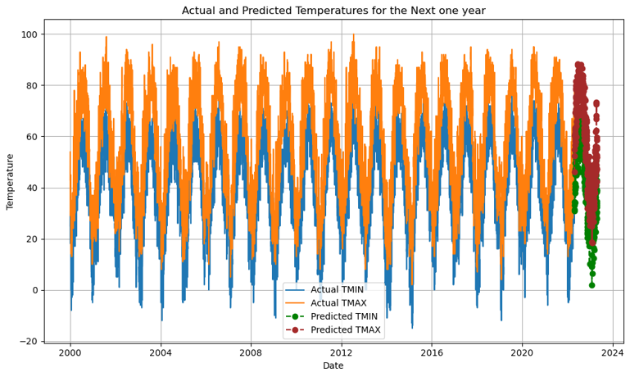
Figure 3-Actual and predicted TMAX and TMIN

By looking at a graph that shows actual and predicted minimum and maximum temperatures for the next year (2024).
Green Line:
- This likely represents the predicted minimum temperatures (TMIN) for 2024. The line will trace a path across the graph, indicating the expected low temperatures throughout the year.
Red Line:
- This most likely represents the predicted maximum temperatures (TMAX) for 2024. Similar to the green line, it will show the expected high temperatures for each date or time period on the x-axis.
The graph allows you to visually compare the predicted minimum and maximum temperatures (green and red lines) with the actual temperatures (which might be represented by another line or markers on the graph,

V.CONCLUSION

We have investigated the use of machine learning methods, specifically the Random Forest algorithm, for weather forecasting in this study. We have proven that using machine learning models to predict minimum and maximum temperatures is both feasible and effective by using a methodical approach to system design, development, and evaluation. We started the system development process by gathering data from multiple sources, such as weather stations, and performing preprocessing operations to deal with missing values and design pertinent features. Because of its capacity to identify nonlinear relationships and perform feature importance analysis, the Random Forest algorithm was chosen. The predictive performance of the trained models was evaluated through rigorous testing and validation using historical weather data following model selection and training. The accuracy of temperature predictions was assessed using performance metrics like root mean squared error (RMSE) and mean absolute error (MAE).
The system development process also brought to light factors to be taken into account when integrating, optimizing performance, and deploying machine learning models in practical applications. Future work could investigate scalability, efficiency, and user interface aspects to improve the system's usability and accessibility, even though the provided code snippet concentrated on training and evaluation.
In conclusion, by shedding light on the technical design, system development procedure, and performance assessment of predictive models, our study adds to the expanding corpus of research on machine learning-based weather forecasting. We can advance the development of more precise and dependable weather forecasts by utilizing machine learning, which will eventually help a number of industries like transportation, agriculture, and disaster preparedness.
The field of weather forecasting will continue to progress in the future thanks to additional study and innovation in machine learning methods, data gathering, and model deployment. This will provide decision-makers with timely and useful information for weather-related risk management and planning.
REFERENCES
[1] Postprocessing of Ensemble Weather Forecast Using Decision Tree–Based Probabilistic Forecasting Methods
P. Benacek +2 more
31 Dec 2022-Weather and Forecasting

[2] Robust weather-adaptive postprocessing using MOS random forests
Achim Zeileis +3 more

[3] Comparing and Interpreting Differently-Designed Random Forests for Next-Day Severe Weather Hazard Prediction
Eric Loken +2 more
03 Apr 2022-Weather and Forecasting

[4] Multi-Mode Integrated Forecast of Surface Temperature based on Random Forest
Shan Luo +5 more

[5] Precipitation Probability Prediction through NWP Bias Correction for South Korea Using Random Forest
Yun Am Seo +1 more
10 Jun 2023-International Journal on Advanced Science, Engineering and Information Technology

